# HTML AND CSS

What is HTML?

* HTML stands for Hyper Text Markup Language
* HTML is the standard markup language for creating Web pages
* HTML describes the structure of a Web page
* HTML consists of a series of elements
* HTML elements tell the browser how to display the content
* HTML elements label pieces of content such as "this is a heading", "this is a paragraph", "this is a link", etc.

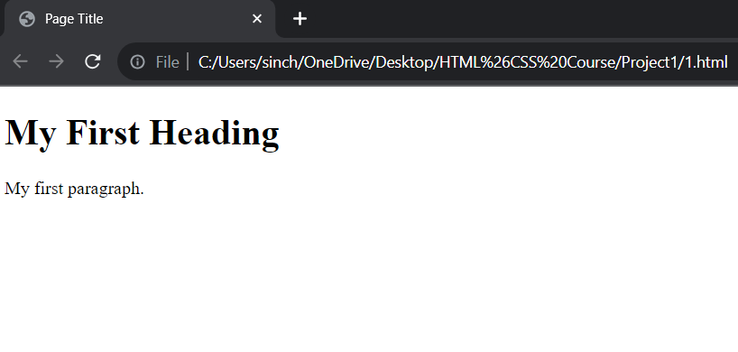A Simple HTML Document

<!DOCTYPE html>   
<html>  
<head

<title>Page Title</title>  
</head>  
<body>  
  
<h1>My First Heading</h1>  
<p>My first paragraph.</p>  
  
</body>  
</html>

Example Explained

* The <!DOCTYPE html> declaration defines that this document is an HTML5 document
* The <html> element is the root element of an HTML page
* The <head> element contains meta information about the HTML page
* The <title> element specifies a title for the HTML page (which is shown in the browser's title bar or in the page's tab)
* The <body> element defines the document's body, and is a container for all the visible contents, such as headings, paragraphs, images, hyperlinks, tables, lists, etc.
* The <h1> element defines a large heading
* The <p> element defines a paragraph

What is an HTML Element?

An HTML element is defined by a start tag, some content, and an end tag:

<tagname> Content goes here... </tagname>

The HTML **element** is everything from the start tag to the end tag:

<h1>My First Heading</h1>

<p>My first paragraph.</p>

## Web Browsers

The purpose of a web browser (Chrome, Edge, Firefox, Safari) is to read HTML documents and display them correctly.

A browser does not display the HTML tags, but uses them to determine how to display the document:

Basic Structure of HTML:

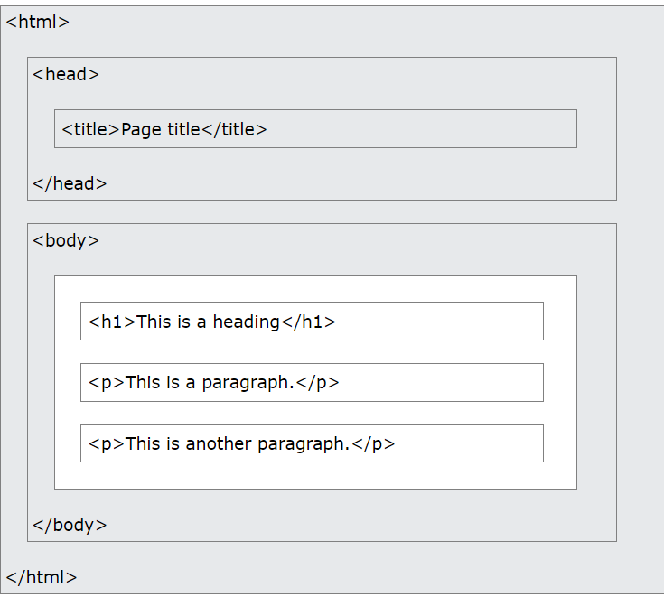

Text HTML Tags:

HTML tags are not case sensitive: <P> means the same as <p>.

HTML Attributes

* All HTML elements can have **attributes**
* Attributes provide **additional information** about elements
* Attributes are always specified in **the start tag**
* Attributes usually come in name/value pairs like: **name="value"**

The href Attribute

The <a> tag defines a hyperlink. The href attribute specifies the URL of the page the link goes to:

The src Attribute

The <img> tag is used to embed an image in an HTML page. The src attribute specifies the path to the image to be displayed:

There are two ways to specify the URL in the src attribute:

**1. Absolute URL** - Links to an external image that is hosted on another website. Example: src="https://www.w3schools.com/images/img_girl.jpg".

**Notes:** External images might be under copyright. If you do not get permission to use it, you may be in violation of copyright laws. In addition, you cannot control external images; it can suddenly be removed or changed.

**2. Relative URL** - Links to an image that is hosted within the website. Here, the URL does not include the domain name. If the URL begins without a slash, it will be relative to the current page. Example: src="img_girl.jpg". If the URL begins with a slash, it will be relative to the domain. Example: src="/images/img_girl.jpg".

**Tip:** It is almost always best to use relative URLs. They will not break if you change domain.

The width and height Attributes

The <img> tag should also contain the width and height attributes, which specify the width and height of the image (in pixels):

The alt Attribute

The required alt attribute for the <img> tag specifies an alternate text for an image, if the image for some reason cannot be displayed. This can be due to a slow connection, or an error in the src attribute, or if the user uses a screen reader.

The style Attribute

The style attribute is used to add styles to an element, such as color, font, size, and more.

The lang Attribute

You should always include the lang attribute inside the <html> tag, to declare the language of the Web page. This is meant to assist search engines and browsers.

The following example specifies English as the language:

<!DOCTYPE html>  
<html lang="en">  
<body>  
...  
</body>  
</html>

Country codes can also be added to the language code in the lang attribute. So, the first two characters define the language of the HTML page, and the last two characters define the country.

The following example specifies English as the language and United States as the country:

<!DOCTYPE html>  
<html lang="en-US">  
<body>  
...  
</body>  
</html>

The title Attribute

The title attribute defines some extra information about an element.

The value of the title attribute will be displayed as a tooltip when you mouse over the element:

<p title="I'm a tooltip">This is a paragraph.</p>

The HTML standard does not require lowercase attribute names.

The title attribute (and all other attributes) can be written with uppercase or lowercase like **title** or **TITLE**.

## Single or Double Quotes?

Double quotes around attribute values are the most common in HTML, but single quotes can also be used.

In some situations, when the attribute value itself contains double quotes, it is necessary to use single quotes:

<p title="John 'ShotGun' Nelson"> **or visa versa**

<p title='John "ShotGun" Nelson'>

All tags with their attributes:

1. <a> (Anchor)
   * href: Specifies the URL of the linked resource.
   * target: Specifies where to open the linked resource (e.g., _blank for a new tab or window).
2. <img> (Image)
   * src: Specifies the source URL of the image.
   * alt: Provides alternative text for the image.
   * width: Specifies the width of the image.
   * height: Specifies the height of the image.
3. <p> (Paragraph)
   * No commonly used attributes other than global attributes like class and style.
4. <div> (Division)
   * No specific attributes, but commonly uses global attributes like class and style.
5. <span>
   * No specific attributes, but commonly uses global attributes like class and style.
6. <h1> to <h6> (Headings)
   * No specific attributes, but commonly uses global attributes like class and style.
7. <ul> (Unordered List)
   * No specific attributes, but commonly uses global attributes like class and style.
8. <ol> (Ordered List)
   * No specific attributes, but commonly uses global attributes like class and style.
9. <li> (List Item)
   * No specific attributes, but commonly uses global attributes like class and style.
10. <table>
    * border: Specifies the width of the border around the table.
    * width: Specifies the width of the table.
    * cellspacing: Specifies the space between cells.
    * cellpadding: Specifies the space between cell content and cell borders.
11. <tr> (Table Row)
    * No specific attributes, but commonly uses global attributes like class and style.
12. <td> (Table Data)
    * colspan: Specifies the number of columns a cell should span.
    * rowspan: Specifies the number of rows a cell should span.
13. <form>
    * action: Specifies the URL where the form data will be submitted.
    * method: Specifies the HTTP method for sending form data (e.g., "GET" or "POST").
14. <input>
    * type: Specifies the type of input (e.g., text, checkbox, radio).
    * name: Specifies the name of the input field.
    * value: Specifies the initial value of the input field.
15. <textarea>
    * name: Specifies the name of the textarea.
    * rows: Specifies the number of visible text lines.
    * cols: Specifies the visible width of the text area.

These are just a few examples, and there are many more HTML tags with their respective attributes. Always refer to the HTML specification or documentation for the most accurate and up-to-date information.